**Exercise 6 – AngularJS Switch**

**Name:** Badri MSV **Roll No:** 195002017

**Subject:** UIT1611 – Web Programming Lab **Faculty:** Dr. S. Sasirekha

**Date:**

**Aim:**

To Design a website using Angular JS to implement switching between layouts using ng-switch.

**Algorithm:**

* Include the AngularJS (load framework) using the script tag.
* Define an ng-app and ng-model directives for the program.
* Get the required inputs using the input tag?
* Use ng-click to add onclick functionality to the buttons, and ng-controller to control the data flow.
* Use ng-hide and ng-show to hide and show elements. (animations)
* Use CSS to function along with ng-hide for animations.
* Use ng-switch to switch between layouts.
* Use above procedure and implement the at least 2 layouts (list and grid).

**Code:**

<!doctype html>

<html lang="en">

<head>

    <title>Angular Animations</title>

    <script src="https://ajax.googleapis.com/ajax/libs/angularjs/1.8.2/angular.min.js"></script>

    <link rel="stylesheet" type="text/css" href="style.css">

</head>

<body ng-app="">

    <!--<select ng-model="weblang">

            <option value="html">HTML

            <option value="css">CSS

            <option value="javascript">JavaScript

        </select>-->

    <input type="text" ng-model="weblang">

    <div ng-switch="weblang">

        <div ng-switch-when="html">

            <h1>HTML</h1>

            <br>

            <em>

                <marquee direction="up">

                    <p>

                        <span class="highlightme">The HyperText Markup Language</span> or HTML is the standard markup

                        language for documents designed to be displayed in a web browser. It can be assisted by

                        technologies such as Cascading Style Sheets (CSS) and scripting languages such as JavaScript.

                        Web browsers receive HTML documents from a web server or from local storage and render the

                        documents into multimedia web pages. HTML describes the structure of a web page semantically and

                        originally included cues for the appearance of the document.

                        HTML elements are the building blocks of HTML pages. With HTML constructs, images and other

                        objects such as interactive forms may be embedded into the rendered page. HTML provides a means

                        to create structured documents by denoting structural semantics for text such as headings,

                        paragraphs, lists, links, quotes and other items. HTML elements are delineated by tags, written

                        using angle brackets. Tags such as "<\img>" and "\<\input>" directly introduce content into the

                                page. Other tags such as "\<\p>" surround and provide information about document text

                                    and may include other tags as sub-elements. Browsers do not display the HTML tags

                                    but use them to interpret the content of the page.

                                    HTML can embed programs written in a scripting language such as JavaScript, which

                                    affects the behavior and content of web pages. Inclusion of CSS defines the look and

                                    layout of content. The World Wide Web Consortium (W3C), former maintainer of the

                                    HTML and current maintainer of the CSS standards, has encouraged the use of CSS over

                                    explicit presentational HTML since 1997.[2] A form of HTML, known as HTML5, is used

                                    to display video and audio, primarily using the "<\canvas>" element, in

                                        collaboration with javascript.

                    </p>

                </marquee>

                <ul>

                    <h1>HTML versions timeline</h1>

                    <li>HTML 2 - November 24th 1995</li>

                    <li>HTML 3 - January 14 1997</li>

                    <li>HTML 4 - December 18 1997</li>

                    <li>HTML 4 - April 24 1998</li>

                    <li>HTML 4 - December 24 1999</li>

                    <li>HTML 4 - May 2000</li>

                    <li>HTML 5 - October 28 2014</li>

                    <li>HTML 5 - November 1 2016</li>

                    <li>HTML 5 - December 14 2017</li>

                </ul>

                <br>

            </em>

        </div>

        <div ng-switch-when="css">

            <h1>CSS</h1>

            <br>

            <em>

                <a href="ex3a.html">Click here to know more about CSS</a>

            </em>

        </div>

        <div ng-switch-when="javascript">

            <h1>JS</h1>

            <br>

            <em>

                <p>

                    <span class="highlightme">JavaScript</span> (/ˈdʒɑːvəskrɪpt/),[10] often abbreviated JS, is a

                    programming language that is one of the core technologies of the World Wide Web, alongside HTML and

                    CSS.[11] Over 97% of websites use JavaScript on the client side for web page behavior,[12] often

                    incorporating third-party libraries.[13] All major web browsers have a dedicated JavaScript engine

                    to execute the code on users' devices.

                    JavaScript is a high-level, often just-in-time compiled language that conforms to the ECMAScript

                    standard.[14] It has dynamic typing, prototype-based object-orientation, and first-class functions.

                    It is multi-paradigm, supporting event-driven, functional, and imperative programming styles. It has

                    application programming interfaces (APIs) for working with text, dates, regular expressions,

                    standard data structures, and the Document Object Model (DOM).

                    The ECMAScript standard does not include any input/output (I/O), such as networking, storage, or

                    graphics facilities. In practice, the web browser or other runtime system provides JavaScript APIs

                    for I/O.

                    JavaScript engines were originally used only in web browsers, but are now core components of some

                    servers and a variety of applications. The most popular runtime system for this usage is Node.js.

                    Although Java and JavaScript are similar in name, syntax, and respective standard libraries, the two

                    languages are distinct and differ greatly in design.

                </p>

            </em>

        </div>

    </div>

</body>

</html>

**Output:**

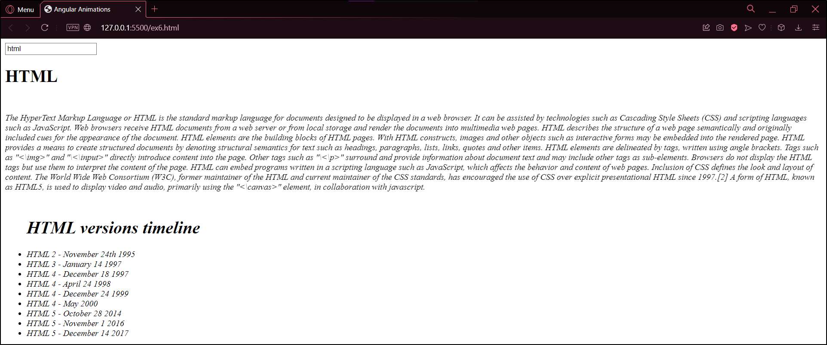

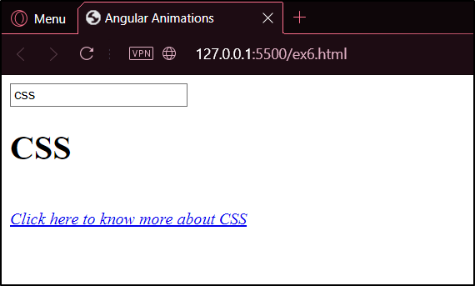

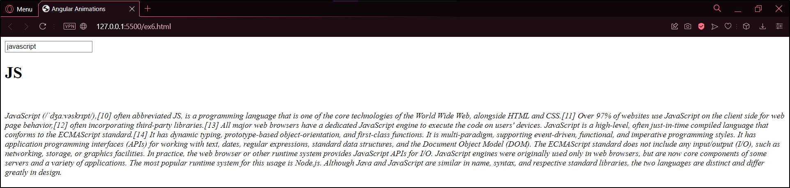

**Result:**

Thus, ng-switch has been implemented successfully to switch between different views.